**DAILY ONLINE ACTIVITIES SUMMARY**

|  |  |  |  |  |  |  |  |  |
| --- | --- | --- | --- | --- | --- | --- | --- | --- |
| **Date:** | **29/05/2020** | | | | | **Name:** | **VIRESH** | |
| **Sem & Sec** | **4th SEM & ‘B’ SEC.** | | | | | **USN:** | **4AL18CS097** | |
| **Online Test Summary** | | | | | | | | |
| **Subject** | | **Operating System** | | | | | | |
| **Max. Marks** | | **30** | | **Score** | | | **22** | |
| **Certification Course Summary** | | | | | | | | |
| **Course** | **Python for Machine Learning** | | | | | | | |
| **Certificate Provider** | | | **Greatlearning Academy** | | **Duration** | | | **5.0 Hrs.** |
| **Coding Challenges** | | | | | | | | |
| **Problem Statement 1:** Write a Java program to Find size of the largest ‘+’ formed by all  ones in a binary matrix  **Problem Statement 2:** Write a C Program to generate first N Armstrong Numbers | | | | | | | | |
| **Status: Done** | | | | | | | | |
| **Uploaded the report in Github** | | | | | **Yes** | | | |
| **If yes Repository name** | | | | | **Lockdown-Coding**  <https://github.com/viresh-kulal/Lockdown-Coding/blob/master/triangularnumbers.c> | | | |
| **Uploaded the report in slack** | | | | | **Yes** | | | |

**Online Test Summary: Today 18CS43 test was scheduled from 09:00am to 09:45pm .The portion for the IA was 2nd module, there were 30questions and the time assigned was 45 minutes the questions were MCQ type.**

**The snapshot of the completion of the test and the marks allotted is attached here.**

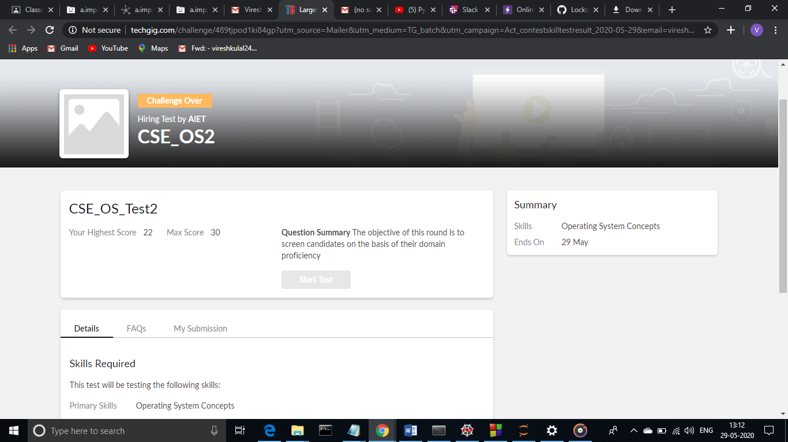

**Online Certification Course Summary: Today I have gone through some tutorials and examples related to numpy and I have learnt about some array concepts like basic operations, universal functions, shape manipulation, stacking together different arrays, advance indexing, indexing with Boolean arrays..etc and some tricks & logics. And also I have gone through python documentation and different doc versions.**

**The snapshots of today’s session is attached below.**

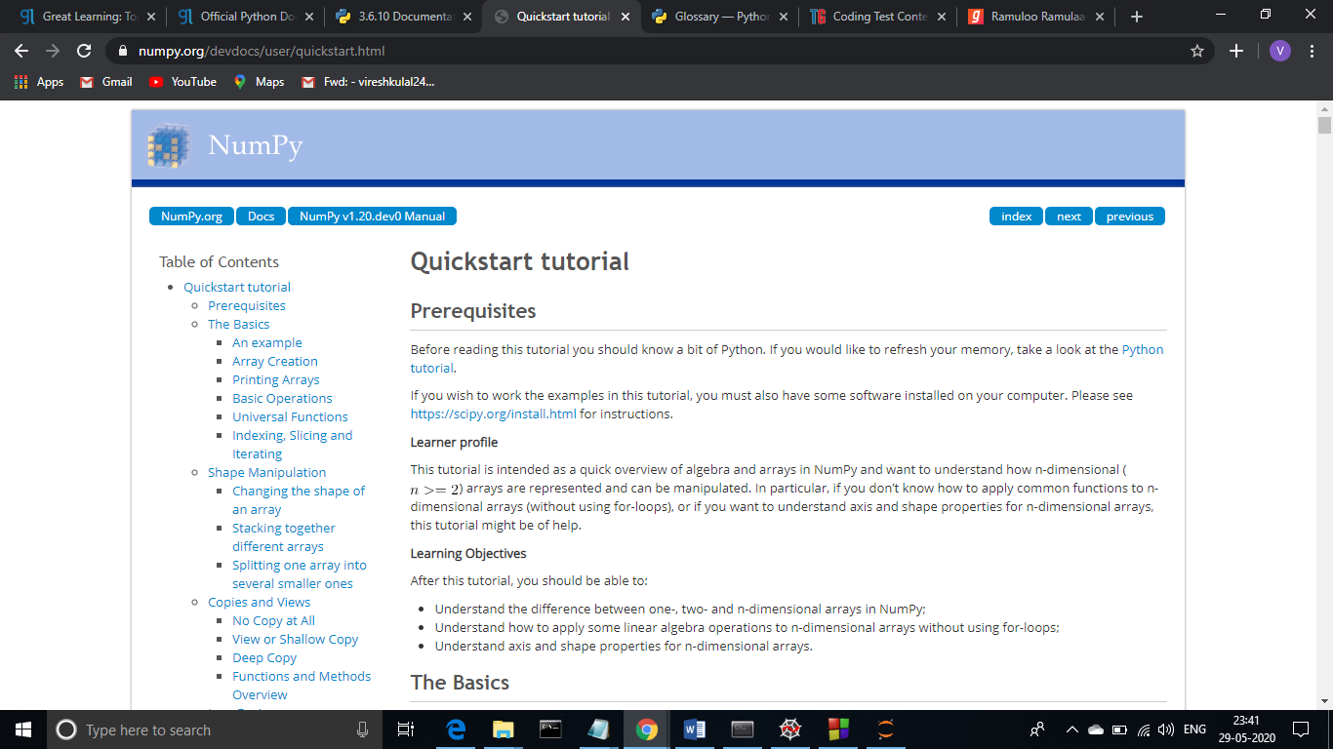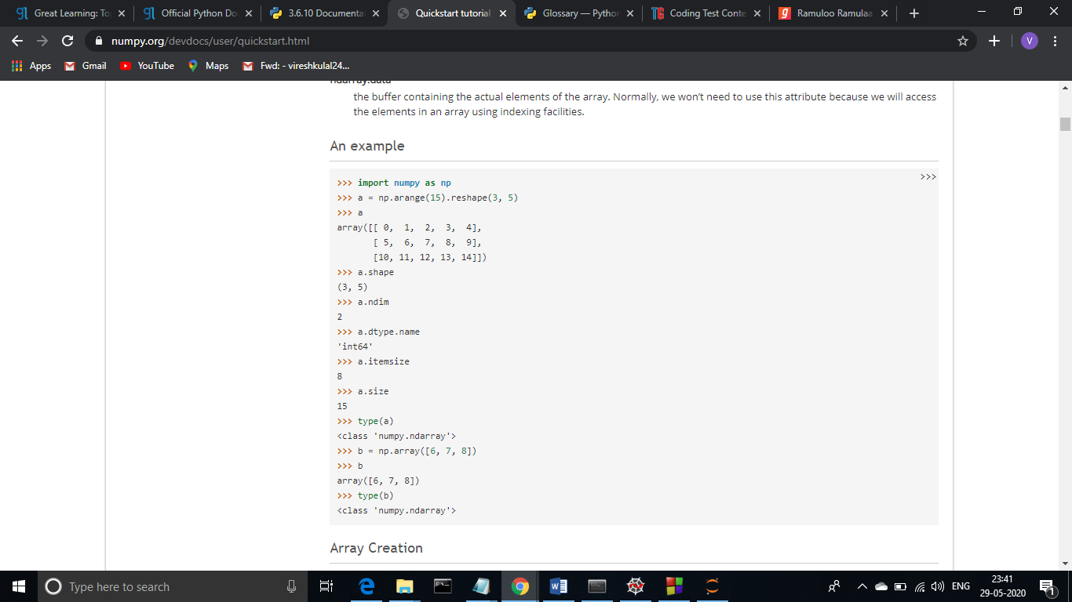 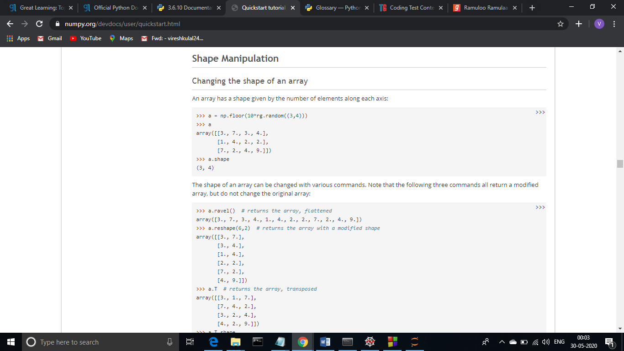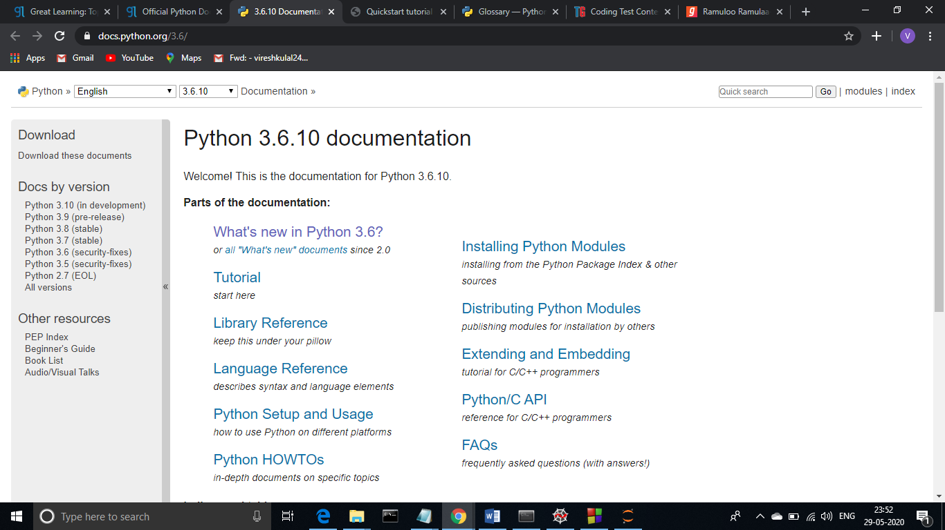

**Online Coding Summary: Today I had received one program from prof. Shilpa CSE Dept. and the other from Prof. Venkatesh CSE Dept. The program is mentioned above in the coding challenges(pg.01). I have also uploaded it to my Github repository.**

The Repository link is:

<https://github.com/viresh-kulal/Lockdown-Coding/blob/master/digital%20root.c>

And the snapshots of the programs A.java and Armstrong.c are attached below.

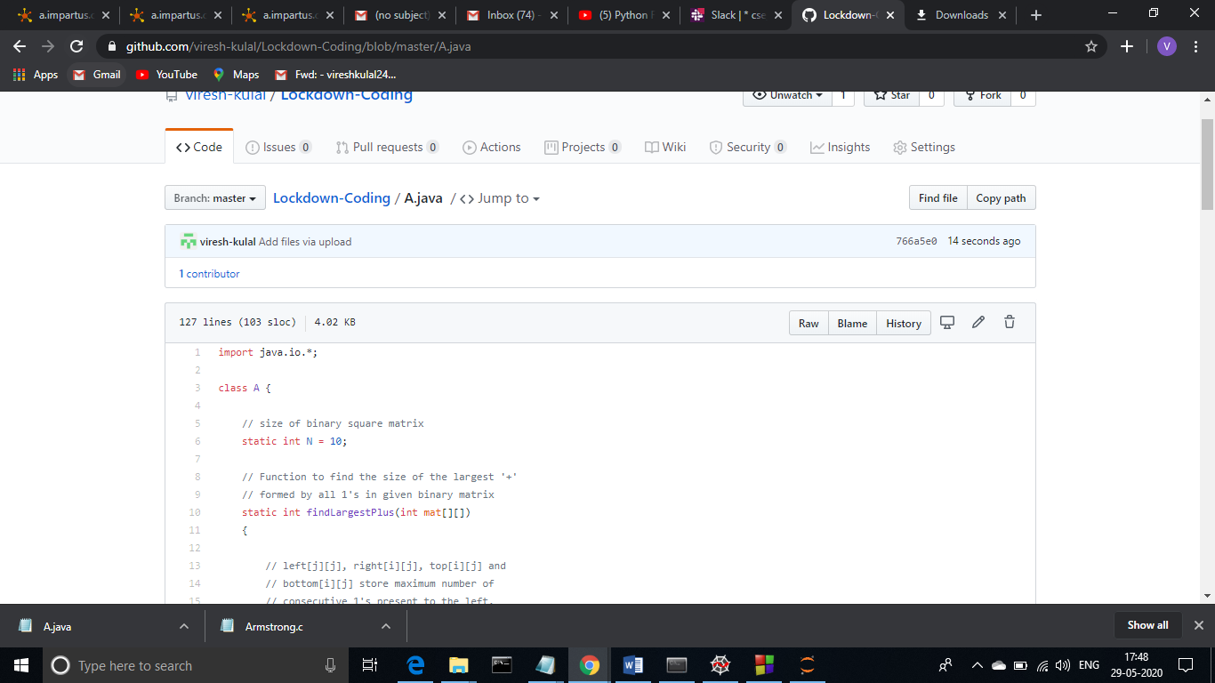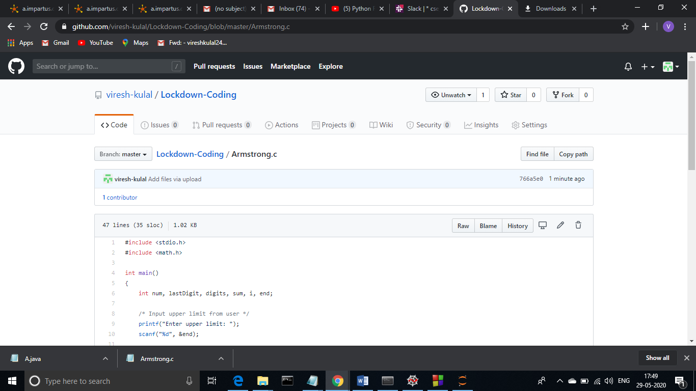**Thank you.**